1️⃣ AI-Based Resume Screening & Ranking System
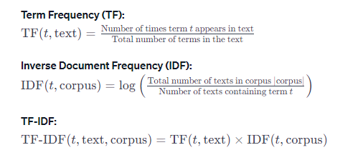
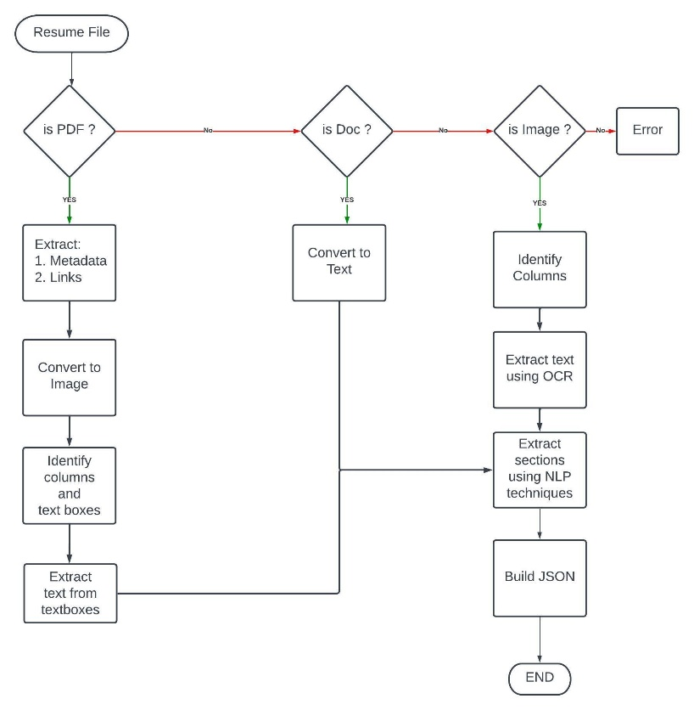

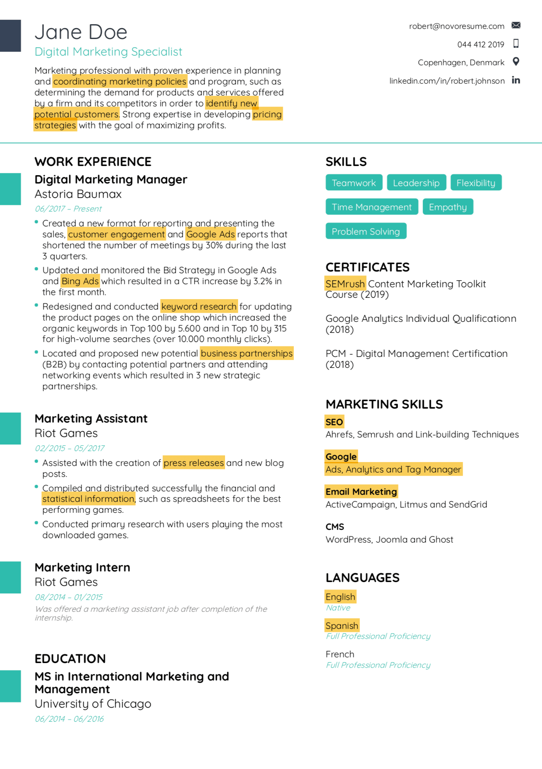
Problem Statement
Automate resume filtering and rank candidates based on job description similarity.
Core Concepts
- NLP
- TF-IDF
- Cosine Similarity
- Keyword extraction
- Basic ML classification
Tools
- Python
- Pandas
- Scikit-learn
- NLTK / spaCy
- PyPDF2
- Matplotlib
Features
- Upload resumes (PDF)
- Extract text
- Compare with Job Description
- Rank candidates
- Skill gap analysis
- Shortlist auto-generation

2️⃣ AI-Based Fake News Detection System
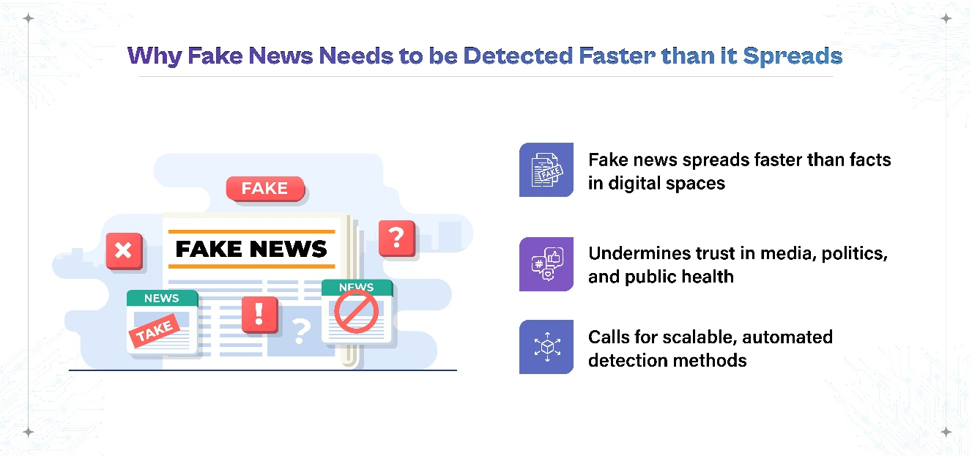
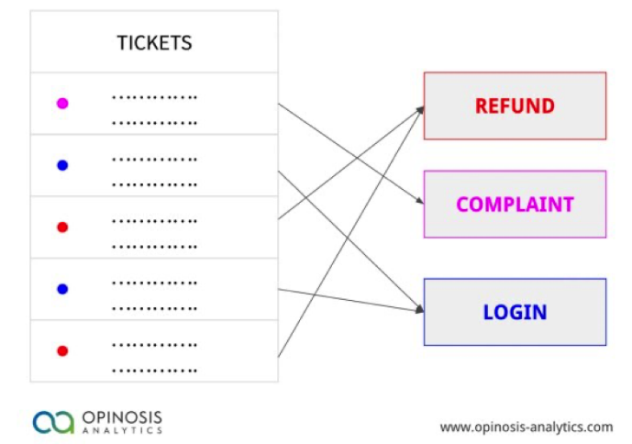
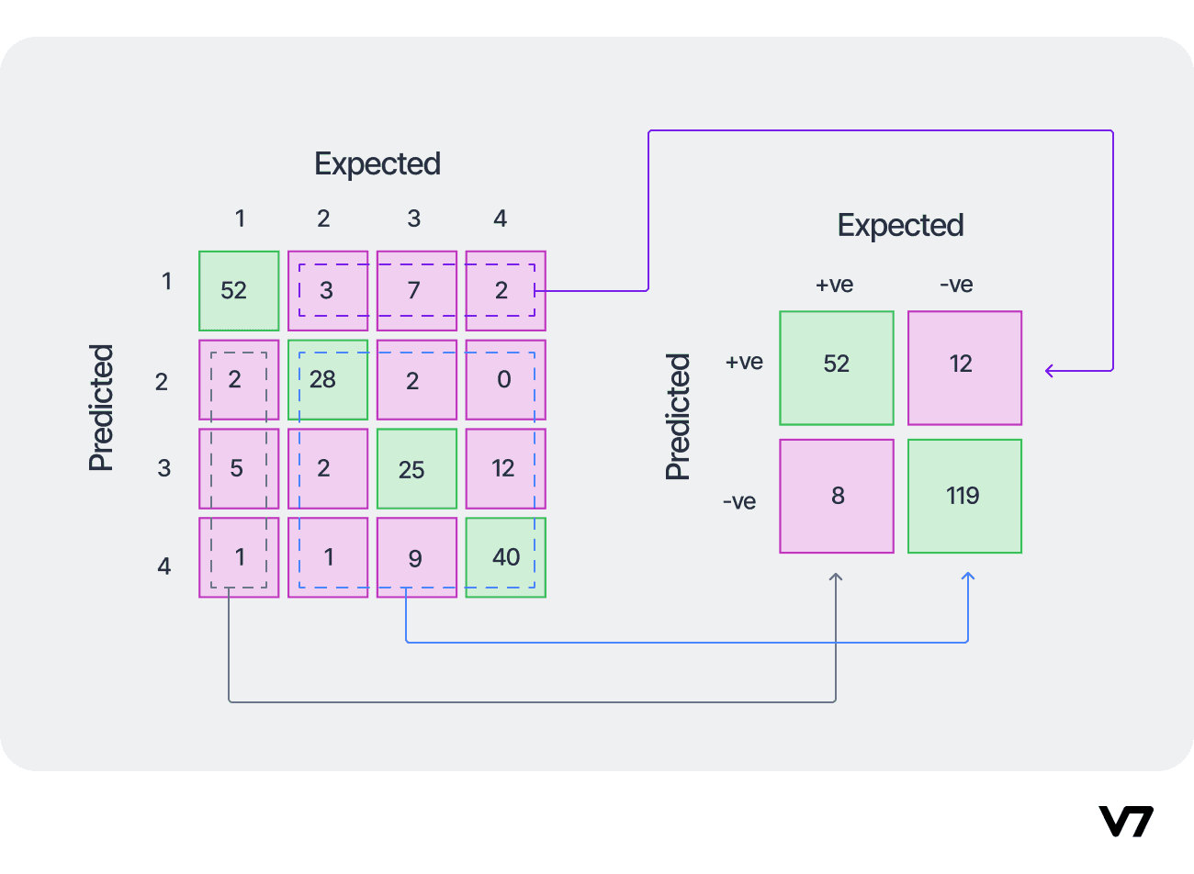
Core
- NLP preprocessing
- Logistic Regression
- Naive Bayes
- LSTM (optional advanced)
Features
- Input article text
- Probability score
- Confidence visualization
- Keyword influence display

3️⃣ Smart Email Spam Classifier
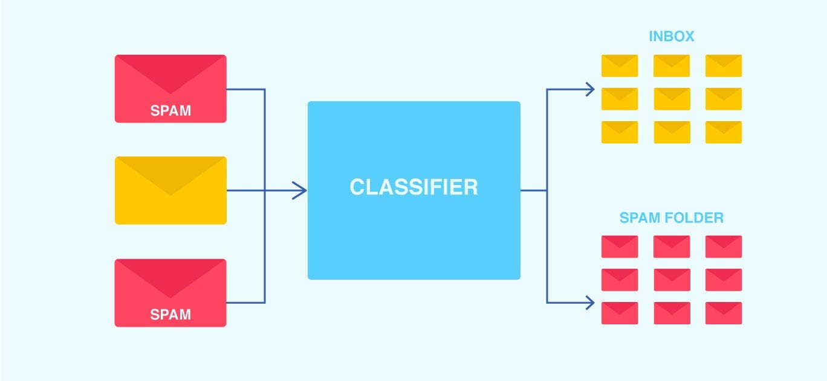
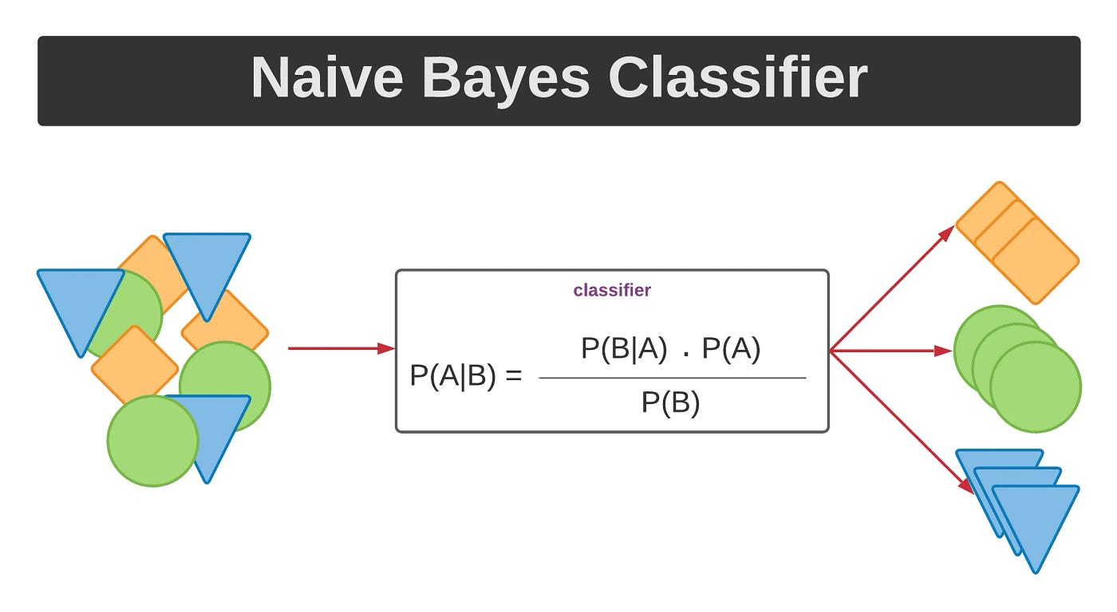
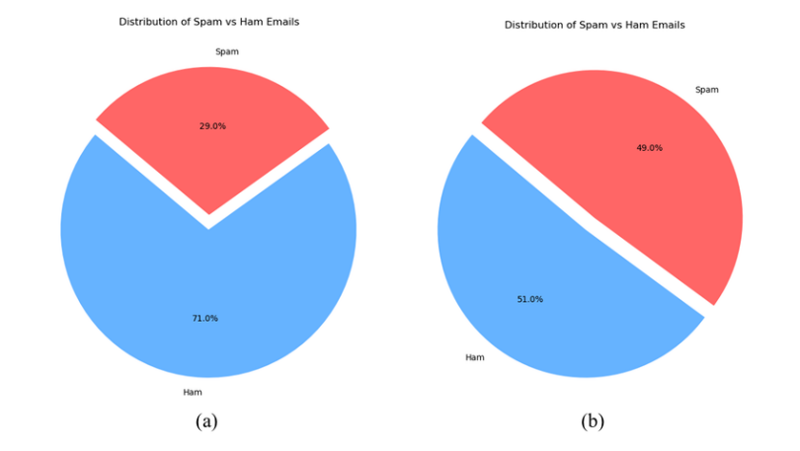
Core
- TF-IDF
- Naive Bayes
- Precision/Recall metrics

4️⃣AI-Based Medical Symptom Checker
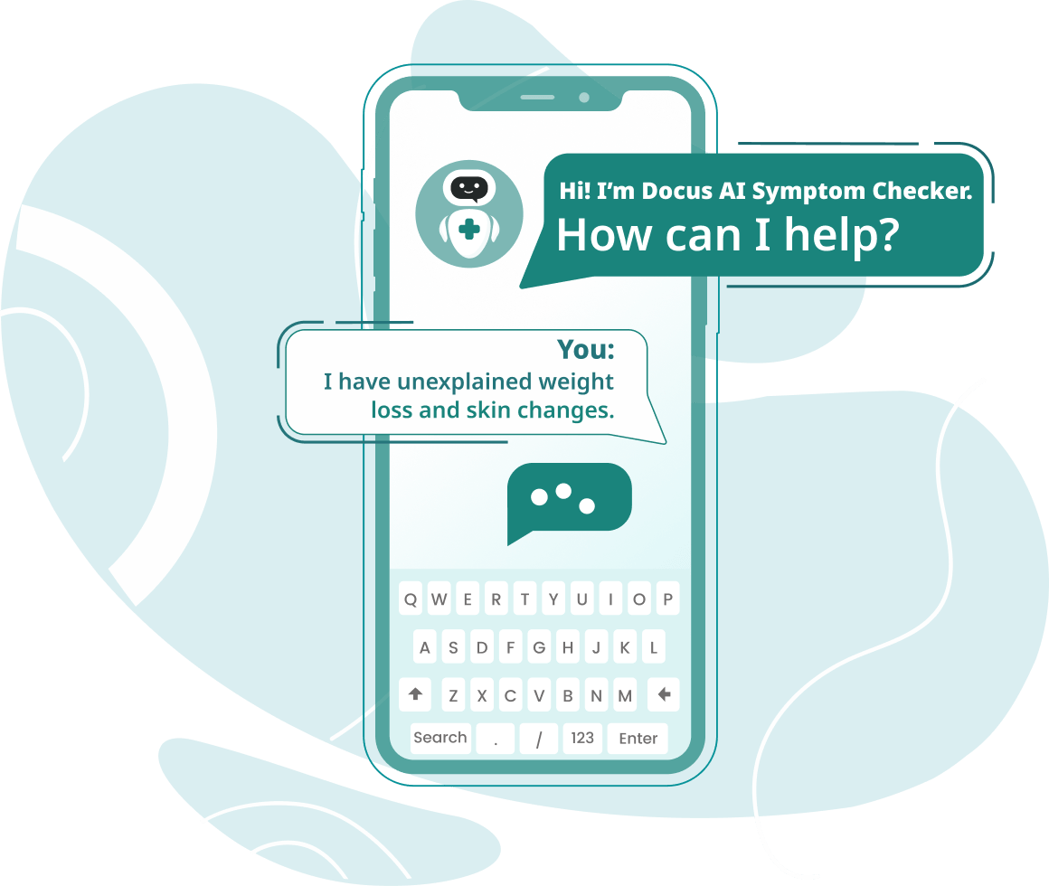
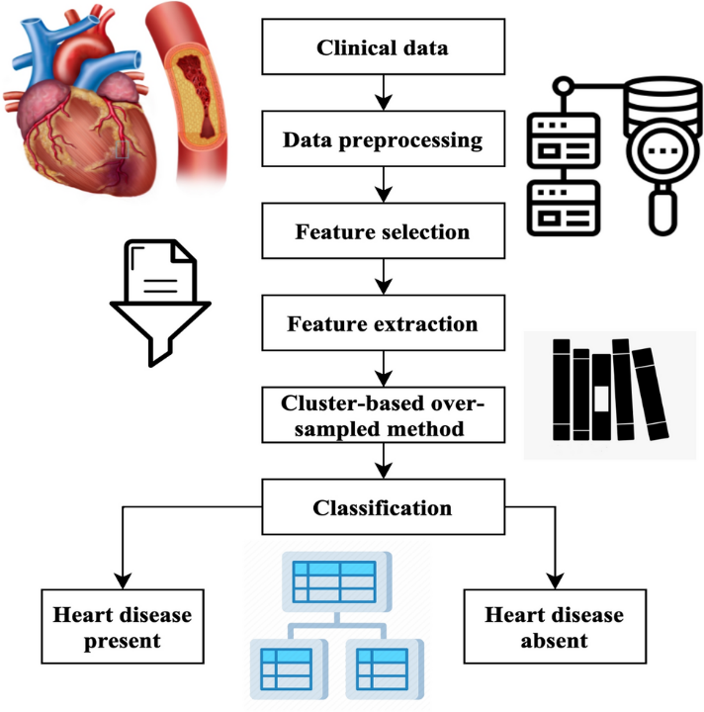
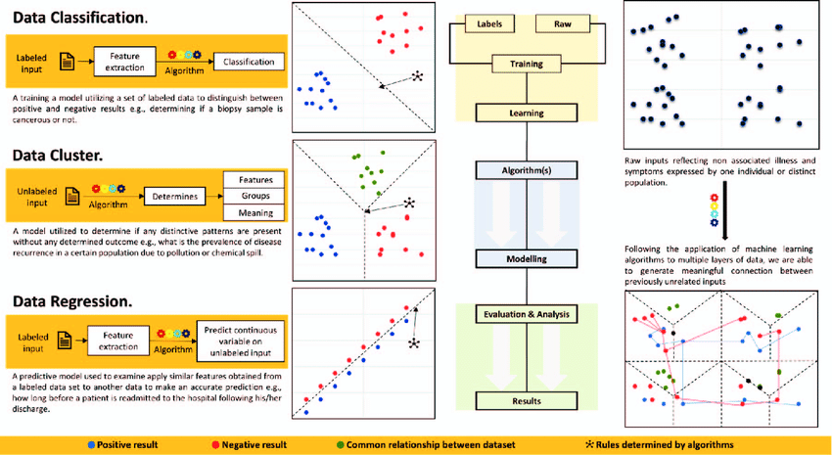
What It Does
User enters symptoms → Model predicts possible disease category.
Model
- Decision Tree
- Random Forest

5️⃣ AI-Based Traffic Flow Prediction
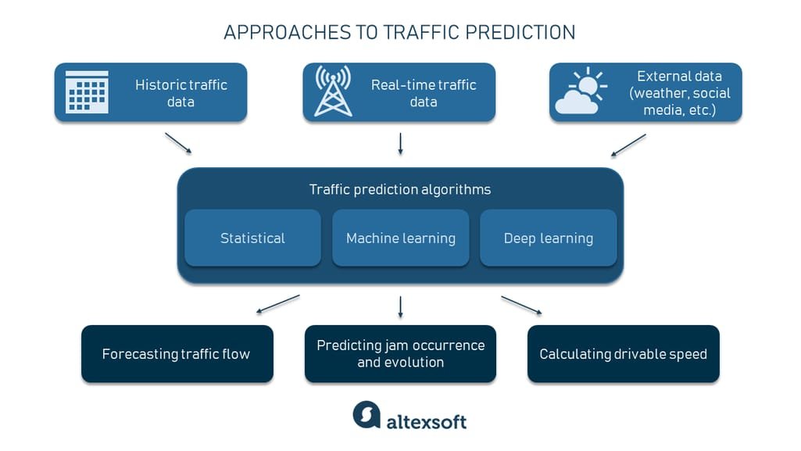
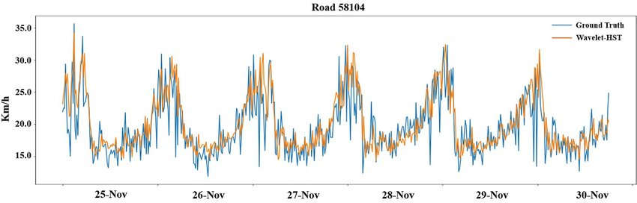
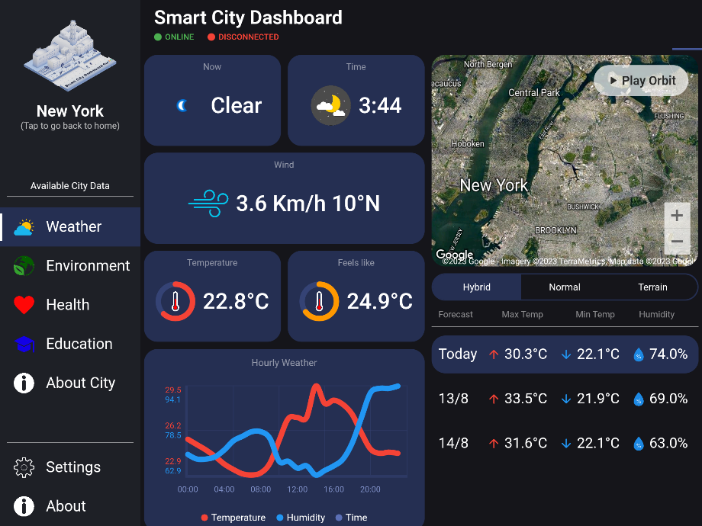
Use Case
Predict peak congestion hours.
Concepts
- Time-series analysis
- Feature engineering
- Forecast modeling

